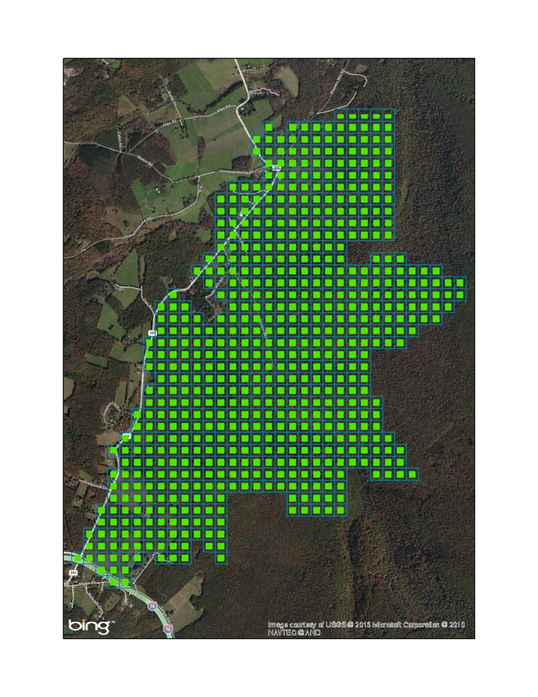

James Whitacre, GIS Manager

Carnegie Museum of Natural History

7/3/2014

Powdermill Nature Reserve Vegetation Survey

Protocols and Standard Operating Procedures

**Powdermill Nature Reserve Vegetation Geodatabase**

|  |  |  |
| --- | --- | --- |
|  | **Feature Class or**  **Table Name** | **Description** |
|  |  | |
|  | **PNR\_VegetationSurvey \_2006\_2008\_v2\_01.mdb** | |
|  |  |  |
|  | VegetationSurveyBlocks | 120 x 120 meter square blocks that contain 9 plots each |
|  | VegetationSurveyPlots | Survey plot points |
|  | Plot\_Data | General information about each plot surveyed |
|  | Herbaceous | Survey of herbaceous plants for surveyed plots |
|  | Dominant\_Shrubs | Survey of dominant shrubs for surveyed plots |
|  | Invasive | Survey of invasive plants for surveyed plots |
|  | Special\_Concern | Survey of special concern plants for surveyed plots |
|  | Trees | Survey of trees for surveyed plots |
|  | Understory | Survey of understory plants for surveyed plots |
|  | CWD | Survey of coarse woody debris for surveyed plots |
|  |  |  |
|  | Only feature classes and data tables are described above. Lookup tables and relationships are not included. | |
|  |  |  |

**Introduction**

During the summers of 2006, 2007, and 2008, Carnegie Museum of Natural History (CMNH) completed an extensive vegetation survey of nearly 2,000 acres of Powdermill Nature Reserve[[1]](#footnote-1) (PNR), located near Ligonier, Pennsylvania. The data collected is stored in an ArcGIS Personal Geodatabase that is also compatible with Microsoft Access. The geodatabase serves as the ecological archive and baseline for PNR, enabling researchers to track the spatial and temporal changes of the reserves vast vegetation resources. The data can also be used to create vegetation maps of PNR, enhance ancillary research, select habitat and vegetation plots, and manage forest resources. This project was funded over several years and began with a generous gift from The Heinz Endowments.

The PNR Vegetation Survey is extensive in its scope and many measures were taken to ensure data content quality and control while collecting data in the field. However, the original, raw form of the geodatabase does not appear to have been maintained consistently throughout the life of the dataset. There were many copies of the Vegetation Survey, many of which contained inconsistent records for the different data tables. Additionally, some minor issues with the structure and design of the geodatabase (i.e. feature classes, data tables, relationships, field names, field order, etc.) have made it difficult to use for research purposes. It is important to note that these issues do not affect the content or validity of the data, just how it is accessed and presented.

Due to these concerns with the data, in January 2013, the database was overhauled to mitigate for these concerns. It was determined that it would be in the best interest of CMNH and PNR to fully evaluate the existing copies of the geodatabase, determine which copy was the most comprehensive, and then rebuild the geodatabase to only include the necessary feature classes, data tables, lookup tables, relationship classes, and data entry forms. This resulted in an upgraded Personal Geodatabase (from ArcGIS 9.2 to ArcGIS 10.0). This format allows the data to continue to be viewed in Microsoft Access and to also utilize the data entry form for viewing the data. This will also allow the same geodatabase schema and protocols to be used for future vegetation surveys of PNR maximizing the geodatabases potential.

This document updates the data collection and entry protocols based on the updates to the geodatabase structure. Additionally, the document provides detailed descriptions of all changes and updates made between the original geodatabase (referred to as version 1.00) and the new geodatabase (referred to as version 2.00).

PNR Vegetation Survey 2006-2008 (v. 2.00): <PNR_VegetationSurvey_2006_2008_v2_00.mdb>

Detailed geodatabase (v. 2.00) schema documentation: <PNR_VegetationSurvey_Schema.xlsx>

PNR Vegetation Survey 2006-2008 (v. 1.00 - Original): <PNR_VegetationSurvey_2006_2008_v1_00_Original.mdb>

Original data entry protocol: [Vegetation Mapping Protocol 2008.doc](Vegetation%20Mapping%20Protocol%202008.doc)

**Data Entry Protocol**

In 2008, a detailed data entry protocol was established as a guide for the PNR Vegetation Survey. The protocol is written as a set of instructions for vegetation surveyors. The following is a slightly modified protocol. Modifications include changes to the general cover class codes to keep the codes sequential. Other modifications include slight changes to clarify and update language.

**Sampling Design**

A continuous grid of 120 meters blocks is laid out in across PNR. In the middle of each block are nine vegetation plots in a 3 x 3 square, the middle plot being the centroid of the block. Each vegetation plot is 10 meters in radius. See Appendix 1 for an illustration of this sampling design.

**Conducting the Survey**

The Vegetation Survey is conducted from leaf-on to leaf-off, approximately from June 1st – September 30th. Surveys can be conducted independently or in pairs. At each point only one surveyor will estimate cover classes, for consistency. The second surveyor can measure trees, identify plants, and/or perform data entry. Surveyors are required to complete training in plant identification, cover class estimation, measurement techniques, and proper equipment use, such as using GPS units and densiometers.

**Photo Documentation**

At the center point of each block, four photos must be taken—one in each of the cardinal directions in the following order: North, East, South, and West. Photos must also be taken of any species of special concern and of any dominant or secondary species that cannot be identified or of any unusual or interesting features.

**Vegetation Data Collection**

Plant Cover Estimation[[2]](#footnote-2)

Cover classes represent the estimated cover of all of the plants in a given physiognomic group. Cover is defined as the percent of the plot that would be covered by the downward vertical projection of the leaf surface area. In the database, the classes are represented as codes defined below.

General Cover Class Codes:

|  |  |  |  |
| --- | --- | --- | --- |
| **0** | Absent | **4** | 26-50% |
| **1** | Trace (1 plant) | **5** | 51-75% |
| **2** | 1-10% (A few plants) | **6** | >75% |
| **3** | 11-25% |  |  |

**0 = Absent**

**1 = Trace,** with < 1% cover. This class is assigned to strata with plants that have small leaf areas (such as graminoids and conifer seedlings) and are widely scattered.

**2 = Barren or barely present,** with 1–10% cover. This is generally assigned to strata with plants that have fairly large leaf areas (such as bracken fern) but are widely scattered in the plot.

**3 = Rare,** with 11–25% cover. This class applies to strata in which the plants are more widely scattered than in “4”. Often, the distinction between “4” and “3” is to separate strata composed primarily of plants with vegetatively reproducing colonies from strata composed of plants reproducing by long rhizomes or seeds.

**4 = Patches,** with 26–50% cover. This class is most often assigned to tree or shrub strata where the plants occur in patches, or to patchy colonies of herbaceous plants.

**5 = Interrupted,** with 51–75% cover. This class is generally assigned to strata with a hole in otherwise continuous coverage, to strata in which the plant canopies do not touch, or to strongly clumped herbaceous or graminoid species where the canopies of the individual clumps do not touch.

**6 = Continuous,** with 76–100% cover. Continuous implies that the cover is distributed evenly across the plot with plant canopies touching and total projected cover exceeding 75%. For some sparsely leaved species, such as needle leaf evergreens and graminoids, the plant canopies may touch, yet not have greater than 75% coverage—these still are designated as having continuous cover.

Entering data

All data is entered directly into tables in ArcPad[[3]](#footnote-3). Each of the following sections describes what data needs to be entered for each section. The process begins by selecting a survey plot in ArcPad. Then tap the feature properties tool to open the forms.

The tables show the attributes of the Vegetation Survey Plots point layer (The PARENT table). The attributes include the **Block\_ID**, **Plot\_ID**, and **Veg\_ID**. The **Plot\_ID** is the unique code for every plot on the reserve and the numbers represent the X's in the following: UTM Easting 64XXXX.000 Northing 444XXXX.000 (Ex. 8111-5174). The **Block\_ID** is the code for the block of nine points which coincides with the Plot\_ID of the center point. The **Veg\_ID** is a unique code that reflects the Block\_ID and the plot location within that block (Ex. 5865-3778-NW).

|  |  |  |  |  |  |
| --- | --- | --- | --- | --- | --- |
| **NW** | Northwest | **N** | North | **NE** | Northeast |
| **W** | West | **C** | Center | **E** | East |
| **SW** | Southwest | **S** | South | **SE** | Southeast |

TABLE : Plot Data

**Date**: Enter the current date.

**Surveyor**: Select the primary surveyor’s name from the drop down list. If the surveyor’s name is not available, the attribute domain may need updated.

**Disturbance**: Note any human disturbance within the 10m radius.

|  |  |  |  |
| --- | --- | --- | --- |
| B | Building | SR | Secondary Unpaved Road |
| N | Net lane | T | Trail |
| NONE | NONE | U | Utility Right-of-Way |
| O | Other (make note) | UNK | Unknown (record error) |
| PR | Primary Paved Road | Y | Yard |

**Canopy Cover**: Using a spherical densiometer take a reading in each of the four cardinal directions. Enter the number of dots COVERED by canopy in the appropriate box. This number should not exceed 96. (See Appendix 2 for proper use of a densiometer.)

**Vegetation Structure:** Estimate total cover (using general cover classes above) within the 10m radius plot for the following height classes to describe the structure of the vegetation. NOTE: We use the densiometer to measure cover of the upper canopy, making it important to try to ignore the mid and lower canopies when making those measurements.

**Mid Canopy** : 2 – 5 meters

**Low layer** : 0.5 – 2 meters

**Ground layer** : ground – 0.5 meters

**Ground Cover Description**

Estimate total cover for each of the following ground cover categories within the 10m radius plot.

|  |  |  |  |  |
| --- | --- | --- | --- | --- |
| **Bare Soil** | **Rocks** | **Ferns** | **Forbs** | **Graminoids** |

**Leaf Litter:** Using a combination of a visual estimate and a depth measurement, determine the average leaf litter abundance within the 10m radius plot.

|  |  |
| --- | --- |
| 0 | Absent |
| 1 | Leaves cover <10% of plot (few scattered leaves) |
| 2 | Leaves cover 10 - 50% of plot and < 5cm deep |
| 3 | Leaves cover >50% of plot and < 5cm deep |
| 4 | Leaves cover 10-50% of plot and > 5cm deep |
| 5 | Leaves cover >50% of plot and > 5cm deep |

**Notes:** Record any notes about the point, i.e. special type of disturbance or other interesting features.

TABLE : Herbaceous

Herbaceous plants are defined as any non-woody vascular plants such as grasses, grass-like plants, forbs, and ferns. Record the five most dominant herbaceous plants and their cover classes within the 10 meter radius plot.

**Species**: Select the scientific name from the drop-down list.

**Cover Class**: Use the general cover classes to estimate the cover of each herbaceous species.

TABLE : Dominant Shrubs

A dominant species is defined as a species that by its size, abundance, or coverage exerts considerable influence upon an association's biotic (such as structure and function) and abiotic (such as shade and relative humidity) conditions. For these surveys, a primary species must make up more than 50% of shrub cover. The secondary species must be clearly the second most dominant species within the shrubs. If a tie exists for the primary or secondary species, then neither is dominant and the species and cover class should not be recorded.

**Species**: Select the scientific name from the drop-down list.

**Cover Class**: Use the general cover classes to estimate the cover of each species of Primary and Secondary shrub.

TABLE : Invasive Species

**Species:** Select the scientific name from the drop-down list.

**Cover Class**: Record the general cover class of each invasive species present in the 10m radius plot.

TABLE : Species of Special Concern

**Species**: Select the scientific name from the drop-down list**.**

**Cover Class**: Record the general cover class of each species of special concern present in the 10m radius plot.

TABLE : Trees

Record and measure each tree > 8cm DBH within the 10-meter radius plot.

**Species**: Select the scientific name from the drop-down list.

After much effort, if the tree can only be identified to genus, select the appropriate Genus code. Collect leaves attached to small branch and bring back to the lab for identification. Take pictures of the bark or any other distinguishing features that may aid in identification.

**DBH (cm)**: Enter the diameter at breast height (DBH), measured in centimeters (to nearest 0.5cm), which is defined as 4.5 feet above the ground. There are some difficulties associated with measuring DBH which are further defined in Appendix 3. Ensure that the diameter side of the tape, not a linear measure, is used.

**Notes:** Record any comments about the tree.

TABLE : Understory

This will help describe the structure of the forest understory. This table consists of **all** **woody plants**, including **trees < 8cm DBH**, **shrubs**, and **vines**. Don’t forget that dwarf shrubs are still shrubs (i.e., Gaultheria procumbens).

For each genus within 5m of the plot center record the cover class within each of the height classes, i.e. 0-0.5m, 0.5-2m and 2-5m.

**Genus**: Select the scientific Genus name from the drop-down list.

**Cover Class**: Assume that you are looking down from above, estimate the amount of ground shadowed by each genus within each height class. Use the general cover classes.

**Notes**: Record any comments about the genus.

TABLE : Coarse Woody Debris

Coarse woody debris (CWD) includes all dead woody material located above the soil, in various stages of decomposition. CWD must be > 5cm in diameter, not self-supporting and leaning at less than 45° from horizontal. Trees and stumps are considered self-supporting.

**Decay Class**: Record decomposition class of each CWD piece > diameter using the classification scheme below. The emphasis is on the wood texture. Other criteria, such as portion on the ground, twigs, bark, shape, and invading roots, are guidelines to the wood texture.

Figure 1. Coarse Woody Debris Decay Classes

**Size class**: Estimate diameter into size class for pieces with decay classes 1-3. Enter nothing for classes 4 & 5.

|  |  |  |
| --- | --- | --- |
| 2 | Sapling | 5 – 15 cm |
| 3 | Pole | 15 – 30 cm |
| 4 | Small | 30 – 60 cm |
| 5 | Medium | 60 – 120 cm |
| 6 | Large | > 120 cm |

**CWD DBH Size classes:**

**Appendix 1. Vegetation Survey Sampling Design for Second Priority Sections of Powdermill Nature Reserve, Westmoreland Co., PA.**

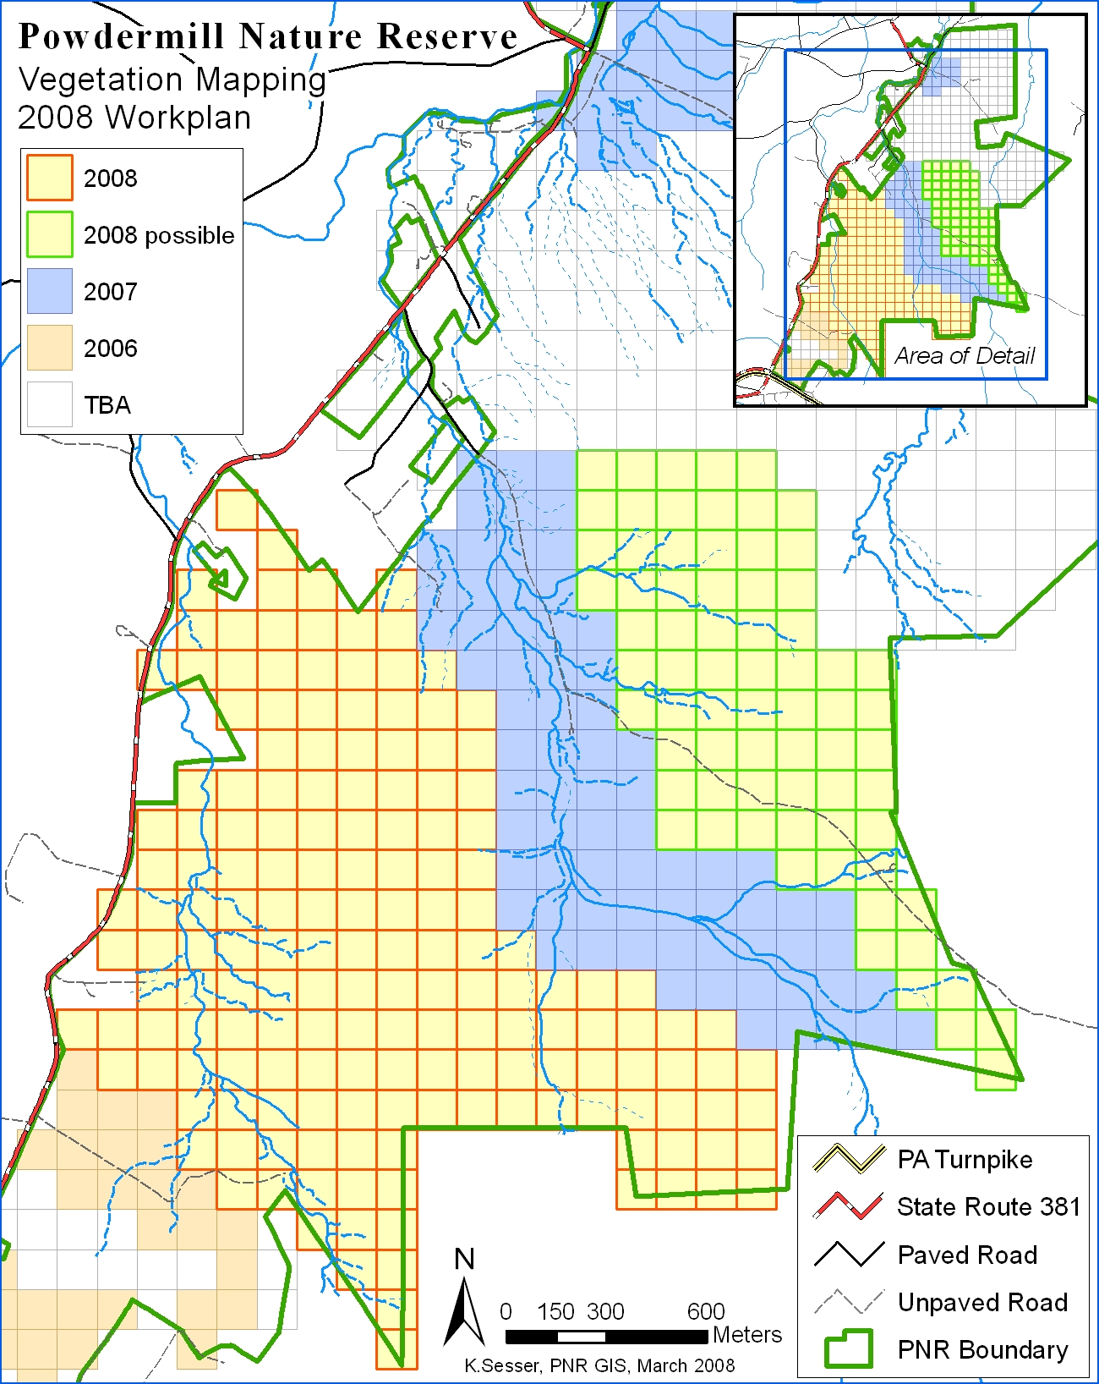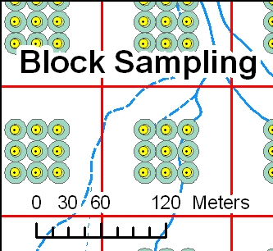

**Appendix 2. Measuring Canopy Cover using a Spherical Densiometer**

1. Generally, you’ll take this reading at the center of the survey plot. However, you want your reading to be representative of the plot, so if the center point is not representative, move to another spot and note where you moved to in the notes field. (I.e., if the plot is treeless except for one tree that happens to be directly above your center point, move at least partially away from that spot.)
2. Your goal is to measure the upper-story tree canopy, not bushy streamside vegetation or a tall patch of witch hazel. If shrubs in the mid-layer get in your way of viewing upper-story canopy cover through the densiometer, you may: try to ignore the understory blockages when you take your readings; or cut away a small amount of brush; or move your location by up to 3 meters. If you ignored brush or moved location, record that in the Notes.
3. Face north and open the densiometer. Hold it about 12” in front of you and at elbow height. Identify a rock or plant directly below the densiometer. Throughout this entire procedure, the densiometer should remain above this spot! The top of your forehead should be visible in the mirror but not the grid area. Close one eye and get your sighting eye in line with the grid centerline. Make sure the densiometer is level by getting the bubble inside of the circle. You will have a “fisheye” view of the canopy cover. Maintain this position while you count.
4. There are four dots in each square of the grid. Count either the dots that are more than half shaded or less than half shaded, depending on which is easier to count. (See sample diagram.) Count systematically, from top row to bottom row, left to right.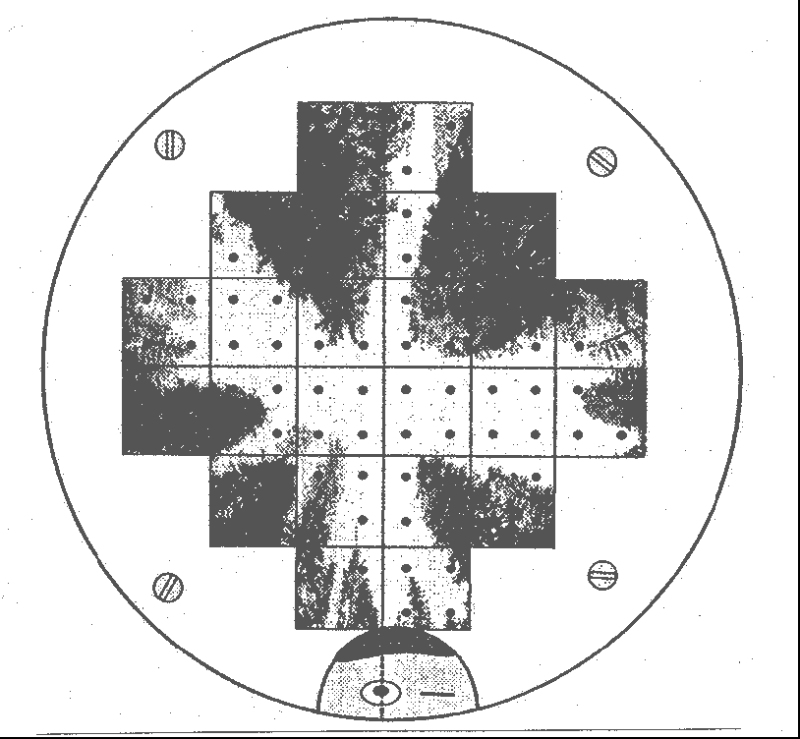 Anything in the upper canopy that shades the dots counts as shade, including tree stems and branches.
5. Record the number of shaded dots in the field labeled Canopy Cover on your mobile device. If you counted un-shaded dots, subtract that number from 96.
6. Interference factors:
   1. Sun glare: Block the reflection using a finger on your free hand.
   2. Wind in the branches: Try to make your count between gusts. If this is not possible, use your best judgment.

Sample spherical densiometer reading.

The above example shows 48 shaded points.

(From Pleus & Schuett-Hames, 1998)

1. Repeat this procedure facing East, South, and then West, turning 90° each time, keeping the densiometer in the same spot and rotating your body around it—remember the rock you identified. Record the number of shaded dots for each direction in the boxes.
2. If possible, have someone else or the same person take the canopy closure readings again, and average them in your field form.

**Appendix 3. Measuring Tree Diameter at Breast Height.**

Text and graphics from Guidelines for Developing and Evaluating Tree Ordinances (<http://www.phytosphere.com/treeord/measuringdbh.htm>, 13 October 2006.)

The Vegetation Survey here at Powdermill Nature Reserve will be measuring trees by their diameter at breast height or DBH. Breast height is 4.5 ft or 1.37m above ground level. DBH is measured with a specially calibrated tape measure called a diameter tape (d-tape). In a tree with a clear gradually tapering trunk, measuring DBH is straightforward, but there are a number of circumstances in which questions arise about how to measure DBH. The following guide can be used to solve some of the more common complications. Use the USDA FS method if an option is illustrated.

1. 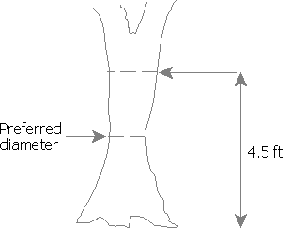**The tree tapers in such a way that the diameter at a point below 4.5 ft is actually smaller than the diameter at 4.5 ft.** Measure diameter at the smallest point and record the height at which diameter was measured on the data sheet.

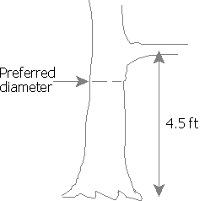

1. **Tree has branches or bumps which interfere with DBH measurement.** Measure DBH below the branch or bump. Some references say to measure a foot below the branching point, which assumes this point is the smallest diameter of the trunk below 4.5 ft. Record the height DBH is measured at.
2. 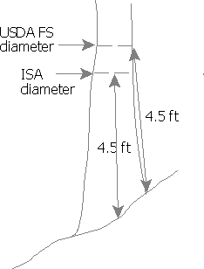**Vertically growing tree is on a slope.** There are several commonly accepted ways to find the DBH height. **Probably the easiest method is to measure diameter 4.5 ft from the ground on the upper side of the slope.** This method is used by the US Forest Service.

**Appendix 3 (continued). Measuring Tree Diameter at Breast Height.**

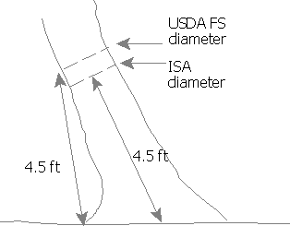

1. **Tree leans.** The US Forest Service measures 4.5 ft up the stem in the direction of the lean.

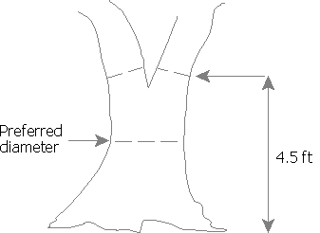

1. **Tree forks below DBH or near DBH.** The measurement is recorded at the narrowest part of the main stem below the fork. The height of the DBH measurement and the fork should be noted (e.g., 85cm diameter @ 0.7m [forks at 1m]).
2. 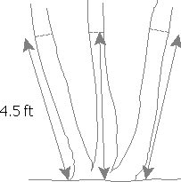**Tree splits into several trunks close to ground level.** Measure DBH of each trunk separately, using the principals shown in categories 1-5 above. The DBH for the tree is found by taking the square root of the sum of all squared stem DBHs.

**Appendix 4. PNR Vegetation Survey Geodatabase Version 2.00 Changes and Known Issues (January 2013)**

Version 2.00 of the PNR Vegetation Survey includes many changes that simplify and upgrade the geodatabase. The geodatabase was completely rebuilt and upgraded to an ArcGIS 10.0 Personal Geodatabase. Other modifications include changes to field names or the field name structure (i.e. caps vs. lower case, underscore placement, etc.) which make the data fields more consistent and clear across data tables. All changes are documented. The overall integrity of the actual data was not compromised and some data was added to the geodatabase, such as elevation values.

**Feature Classes**

* Vegetation Survey Blocks
  + Previous name: Blocks
  + In Microsoft Access, Block\_ID field was set as the key field.
  + Inside\_PNR\_Bndy: Renamed from INSIDE\_BNDY
  + Survey\_Complete: Renamed from VEG\_DONE. This field was reanalyzed. If a block had at least one survey on it, it was considered complete.
  + Survey\_Year: Renamed from VEG\_YEAR. The value “0” was replaced with a null value.
  + Plot\_Count: Added field. This field represents the number of plots in the block that were surveyed.
  + UTM\_Coord\_E: Renamed from X. Calculated at center of block using UTM Zone 17N in NAD 83 datum.
  + UTM\_Coord\_N: Renamed from Y. Calculated at center of block using UTM Zone 17N in NAD 83 datum.
  + Latitude: Added field. Calculated at center of block using NAD 83 datum.
  + Longitude: Added field. Calculated at center of block using NAD 83 datum.
  + Elevation\_m: Added field. Calculated using PNR DEM 5m (derived from PAMAP LiDAR data) as an average in the block.
  + Aspect\_deg: Added field. Calculated aspect direction, as derived from PNR DEM 5m (derived from PAMAP LiDAR data), as an average of all 5m cells in the block.
  + Slope\_deg: Added field. Calculated slope angle, as derived from PNR DEM 5m (derived from PAMAP LiDAR data), as an average of all 5m cells in the block.
* Vegetation Survey Plots
  + Previous name: VegMapping\_points\_all
  + Survey\_Complete: Renamed from VEG\_DONE. This field was reanalyzed. If a plot had a Plot Data record for the Plot ID, it was considered complete.
  + Survey\_Year: Renamed from VEG\_YEAR. The value “0” was replaced with a null value.
  + UTM\_Coord\_E: Renamed from X. Calculated at center of block using UTM Zone 17N in NAD 83 datum.
  + UTM\_Coord\_N: Renamed from Y. Calculated at center of block using UTM Zone 17N in NAD 83 datum.
  + Latitude: Added field. Calculated at center of block using NAD 83 datum.
  + Longitude: Added field. Calculated at center of block using NAD 83 datum.
  + Elevation\_m: Added field. The elevation of the PNR DEM 5m (derived from PAMAP LiDAR data) cell that intersects the plot point.
  + Aspect\_deg: Added field. The aspect direction cell, as derived from the PNR DEM 5m (derived from PAMAP LiDAR data), that intersects the plot point.
  + Slope\_deg: Added field. The slope angle cell, as derived from the PNR DEM 5m (derived from PAMAP LiDAR data), that intersects the plot point.
* Deleted Feature Classes
  + VegMapping\_Points\_2008
  + XY\_Veg\_Pts\_ALL
  + These feature classes were deleted because there was no need to keep them. All data stored in both datasets exists in Vegetation Survey Plots feature class or could be added without compromising database performance and use.

**Main Data Tables**

* All Tables
  + All tables were properly formatted and sorted.
  + OBJECTID: In Microsoft Access, field was set as the primary key field.
  + Plot\_ID: Renamed from GRID\_ID and moved to the second field slot after OBJECTID.
  + Notes: Field type was changed to text with a length of 255. This was not consistent. For all values, the word “Grid” was replaced with the word “Plot”.
  + dbase: moved to the end of all tables
  + No additional fields were added to any data tables.
  + For any field using the Cover Class domain, values “4”, “5”, “6”, and “7” were changed to “3”, “4”, “5”, and “6”, respectively (see explanation in **Lookup Tables and Attribute Domains** under Cover Class General).
* Herbaceous
  + The herbaceous table included records with repeat OBJECTID values. This is a result of poor data import/record append methods or something became corrupt. Therefore, this table had to be rebuilt. This was performed in Microsoft Access. Upon completion, all ArcGIS attribute domains were retained.
  + Step 1: Right click the Herbaceous table and click Copy.
  + Step 2: Right click anywhere in Navigation Pane and click Paste. Use the default name. Select the *Structure Only* option. This results in a table with the correct field definitions, but no data.
  + Step 3: Delete the OBJECTID field from the original Herbaceous table.
  + Step 4: Right click anywhere in Navigation Pane and click Paste. The default name should be the same, if not match it to first pasted table. Select the *Append Data to Existing Table* option. This will paste all data into the correct fields and automatically populate the OBJECTID field.
  + Step 5: Delete the original Herbaceous table. Click yes when asked if relationships should also be deleted.
  + Step 6: Recreate the relationships: 1. VegetationSurveyPlots.Plot\_ID to Herbaceous.Plot\_ID; 2. Herbaceous.Plant\_Code to tlu\_HERBACEOUS.CODE
* Plot Data
  + Leaf\_Litter\_Abun: Renamed from LeafLitter\_Abun.
* Understory
  + CC\_0\_05, CC\_05\_2, and CC\_2\_5: These fields contained the value “3”, which was removed as an invalid code at some point (see explanation in **Lookup Tables and Attribute Domains** under Cover Class General). Therefore, the values of those fields were adjusted so that existing coded values of “3” were changed to “2” and “4”, “5”, “6”, and “7” were also changed to “3”, “4”, “5”, and “6”, respectively.

**Lookup Tables and Attribute Domains**[[4]](#footnote-4)

* All Lookup Tables and Attribute Domains
  + All ArcGIS coded domains contain a lookup table for use in Microsoft Access. However, ArcGIS range domains were not setup in Microsoft Access as validation rules.
  + OBJECTID: Added to all tables for better use in ArcGIS. In Microsoft Access, field was set as the primary key field.
  + Code: Moved to the first field; set as the primary key
  + Species: All values were checked for to ensure
  + Scientific: If Species field is “spp.”, then “spp.” was ensured to be added to the scientific name. This field was used for the Description of coded domains for any species lists.
  + Rank: Moved to the last field
* Cover Class General
  + The Vegetation Mapping Protocol from 2008 indicates that a coded value of “3” existed at one point, but was later lumped into coded value “2”, thus eliminating coded value “3”. However, the understory data table still included the coded value “3” for its 3 fields that use the Cover Class General domain. Therefore, the values of those fields were adjusted so that existing coded values of “3” were changed to “2” and “4”, “5”, “6”, and “7” were also changed to “3”, “4”, “5”, and “6”, respectively. For all other tables, the values were adjusted to match the new coded domain. Great care was taken to ensure that value replacement did not accidentally change the values incorrectly. The order of replacement was very important, so “3”s were changed to “2” first, meaning “3”s were eliminated from the data. This freed up “4”s to be changed to “3”s. This pattern then cascaded to the other values.
* Understory Genus
  + Genus: In the ArcGIS coded domain, the Genus field is used for both the code and the description.

**Relationships**[[5]](#footnote-5)

* ArcGIS Relationship Classes:
  + All relationship classes were recreated using the new schema.
  + Added a relationship class between the Vegetation Survey Blocks and Vegetation Survey Plots.
  + All relationship classes with the deleted feature classes were also deleted.
* Microsoft Access Primary Relationships: All relationships with the deleted feature classes were also deleted.
* Microsoft Access Secondary Relationships: These include relationships to lookup tables. Removed all relationships to the Cover Class General lookup table. This is because a query on these parameters is not likely. All other secondary relationships were retained.

**Cartographic Issues**

A custom projection was used to create the features of the spatial data (Vegetation Survey Blocks and Plots). The projection used is the Albers projection with North American Datum 1983. This projection is not a conventional projection used for southern Pennsylvania. A different projection, such as Pennsylvania State Plane South or UTM Zone 17 North, would have been ideal; however, the projection has not been changed. The projection was not changed because when viewed in the custom Albers projection, the Vegetation Survey Block polygon feature class lines up to grid north. When transformed to a different projection, the blocks appear tilted and this affects the cartographic appearance. Additionally, it is unclear why this projection was initially used, as there is no documentation explaining why. Because of this fact, it was determined that the projection should not be altered until more information is known. Other projections can be used for analysis.

**Appendix 5. PNR Vegetation Survey Geodatabase Version 2.01 Changes (April 2013)**

In version 2.01 of the PNR Vegetation Survey, the feature classes were re-projected to Pennsylvania State Plane South NAD 83 meters projection. Below is the list of steps that were followed to accomplish the projection transformation.

* In **ArcCatalog**, copy **PNR\_VegetationSurvey \_2006\_2008\_v2\_00.mdb** into the same folder and rename it **PNR\_VegetationSurvey \_2006\_2008\_v2\_01.mdb**.
* Delete all *records* from the feature classes and data tables using the **Truncate Table** tool. This removes all data. *The lookup tables should remain intact*.
* Close **ArcCatalog** and reopen the new personal geodatabase (**PNR\_VegetationSurvey \_2006\_2008\_v2\_01.mdb**) using **Microsoft Access**.
* In **Microsoft Access**, navigate to the **Database Tools** ribbon and click on **Compact and Repair Database**. This will reset the tables to start the records with OBJECTID 1. Close **Microsoft Access** and reopen **ArcCatalog**. Navigate to the **PNR\_VegetationSurvey \_2006\_2008\_v2\_01.mdb** location.
* Open the feature class properties for both feature classes and complete the following:
  + **XY Coordinate** tab: Re-assign the projection to **NAD\_1983\_StatePlane\_Pennsylvania\_South\_FIPS\_3702 (WKID: 32129)**
  + **Feature Extent** tab: **XY Extent**, click **Recalculate**.

***The result to this point is essentially the schema of the geodatabase with a new projection.***

* Using the **Project Tool**, project the version 2.00 feature classes from **albers83** to **NAD\_1983\_StatePlane\_Pennsylvania\_South\_FIPS\_3702 (WKID: 32129)**. Save the new feature classes in the new version 2.01 geodatabase.
* Using the **Append Tool**, append all features from the re-projected feature classes to the empty feature classes in the new version 2.01 geodatabase.
* Open the feature class properties for both feature classes and **Recalculate** the **XY Extent** in the **Feature Extent** tab. This will allow for better viewing of the feature class.
* Using the **Append Tool**, append all records from the 8 data tables from the old version 2.00 to the new version 2.01.
* Double check the geodatabase in both ArcMap and Microsoft Access ensure all records were transferred and that all relationships still work.
* Recreate a version 2.01 ArcMap document.

1. Powdermill Nature Reserve is the environmental research center of Carnegie Museum of Natural History. [↑](#footnote-ref-1)
2. The General Cover Classes used for the original 2008 protocol are different; however, they were adjusted in the geodatabase update. See explanation in the appendix under Lookup Tables and Attribute Domains under Cover Class General. [↑](#footnote-ref-2)
3. Data can also be entered via Microsoft Access through the data entry form. Also, the ArcPad version initially used is not compatible with ArcGIS 10+. Therefore if this protocol should be used for future vegetation surveys, a new ArcPad project will need to be created. [↑](#footnote-ref-3)
4. Lookup tables are for use primarily in Microsoft Access to validate data entry. ArcGIS utilizes attribute domains to validate data entry. Lookup tables and attribute domains provide similar function, but are not interchangeable between ArcGIS and Microsoft Access and therefore must be created for use in both systems. Queries in both systems, however, may use lookup tables. [↑](#footnote-ref-4)
5. Relationship classes are only visible in ArcGIS and they operate very similar to relationships in Microsoft Access. However, they are not interchangeable between ArcGIS and Microsoft Access. Relationships in Microsoft Access must be created separately. [↑](#footnote-ref-5)